Experiment 3: Naive Bayes Classifier (Spam/Ham-style)
ED408 — Statistical / Supervised Machine Learning Lab
Aim: Apply a Naive Bayes classifier to a spam-vs-ham-style binary classification problem.
Dataset Used: BSDS500 (Berkeley Segmentation Data Set) ships as natural images with hand-annotated object-boundary ground truth, not a tabular dataset. It was converted into a tabular binary-classification dataset (data/bsds_features.csv, built by scripts/build_dataset.py): one row per sampled pixel from all 200 BSDS500 training images, 10 features (R, G, B, gray, grad_mag, grad_dir, laplacian, local_std, x_norm, y_norm) capturing colour, gradient, texture and position, and label is_edge (1 if a majority of 6 human annotators marked the pixel as a segment boundary, else 0). 24,000 rows total, perfectly balanced (12,000 / 12,000). This same dataset is reused, unchanged, for every question in this lab. Per lab instructions this same dataset (not an email corpus) is used here too: 'edge' plays the role of 'spam' and 'non-edge' the role of 'ham', with pixel colour/gradient/texture features standing in for word/token features.
Theory
Naive Bayes applies Bayes' theorem with a (naive) assumption that features are conditionally independent given the class. GaussianNB models each feature, per class, as a 1-D Gaussian and multiplies per-feature likelihoods to score each class, predicting the class with the highest posterior probability. It is fast, needs little data, and is a classic baseline for spam/ham-style filtering.
Code
"""
Q3 — Naive Bayes classifier ("spam vs ham" style binary classification),
applied to the BSDS500-derived edge-pixel dataset.

Adaptation note: the lab asks for spam/ham email classification, but per
lab instructions every question must use the BSDS500-derived dataset only.
We treat it as the same kind of problem Naive Bayes is classically used
for: binary classification from a feature vector under a conditional
independence assumption -- here "edge" plays the role of "spam" and
"non-edge" the role of "ham", with pixel colour/gradient/texture features
in place of word/token features.
"""
import numpy as np
import matplotlib.pyplot as plt
from sklearn.naive_bayes import GaussianNB
from sklearn.metrics import (accuracy_score, confusion_matrix,
classification_report, RocCurveDisplay)

from common import load_split, save_metrics, FIG_DIR

def main():
# GaussianNB is not scale-sensitive, but scaling keeps things consistent
# with the other questions and doesn't change its predictions.
X_train, X_test, y_train, y_test = load_split(scale=False)
print(f"train={X_train.shape}, test={X_test.shape}")

clf = GaussianNB()
clf.fit(X_train, y_train)

preds = clf.predict(X_test)
probs = clf.predict_proba(X_test)[:, 1]

acc = accuracy_score(y_test, preds)
cm = confusion_matrix(y_test, preds)
report = classification_report(y_test, preds, target_names=["ham (non-edge)", "spam (edge)"])
print(f"Test accuracy: {acc:.4f}")
print(report)

fig, ax = plt.subplots(figsize=(4.5, 4))
im = ax.imshow(cm, cmap="Greens")
for i in range(2):
for j in range(2):
ax.text(j, i, cm[i, j], ha="center", va="center",
color="white" if cm[i, j] > cm.max() / 2 else "black")
ax.set_xticks([0, 1]); ax.set_xticklabels(["ham", "spam"])
ax.set_yticks([0, 1]); ax.set_yticklabels(["ham", "spam"])
ax.set_xlabel("Predicted"); ax.set_ylabel("Actual")
ax.set_title("Naive Bayes Confusion Matrix")
plt.tight_layout()
plt.savefig(FIG_DIR / "q3_nb_confusion_matrix.png", bbox_inches="tight")
plt.close()

fig, ax = plt.subplots(figsize=(5, 5))
RocCurveDisplay.from_predictions(y_test, probs, ax=ax, name="GaussianNB")
ax.plot([0, 1], [0, 1], "k--", alpha=0.4)
ax.set_title("Naive Bayes ROC Curve")
plt.tight_layout()
plt.savefig(FIG_DIR / "q3_nb_roc.png", bbox_inches="tight")
plt.close()

save_metrics("q3_naive_bayes", {
"test_accuracy": acc,
"confusion_matrix": cm.tolist(),
"classification_report": report,
"class_priors": clf.class_prior_.tolist(),
})

if __name__ == "__main__":
main()
Output
 | Pred: ham | Pred: spam
Actual: ham | 2046 | 354
Actual: spam | 1161 | 1239

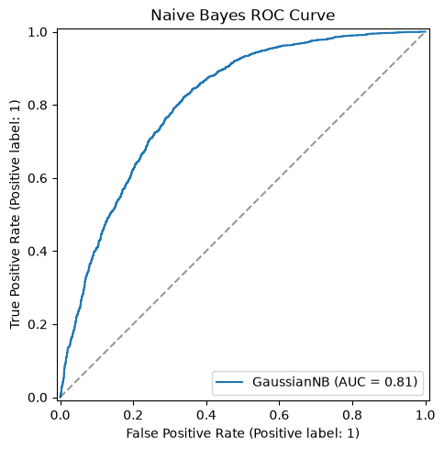
ROC curve for the Naive Bayes classifier.
Result
GaussianNB achieved 68.44% test accuracy. It underperforms the Decision Tree / SVM because the independence assumption is violated (grad_mag, laplacian and local_std are all correlated), but it remains a fast, reasonable baseline.

